H3-Healthcare – Patient Tracker SharePoint Data retravel App
Step 1: Create the project
Open Visual Studio
Terminal New Terminal move to Project folder
PS C:\Development\CodeApps>
Run following comment
npx degit github:microsoft/PowerAppsCodeApps/templates/vite SharePoint-DataApp
cd SharePoint-DataApp
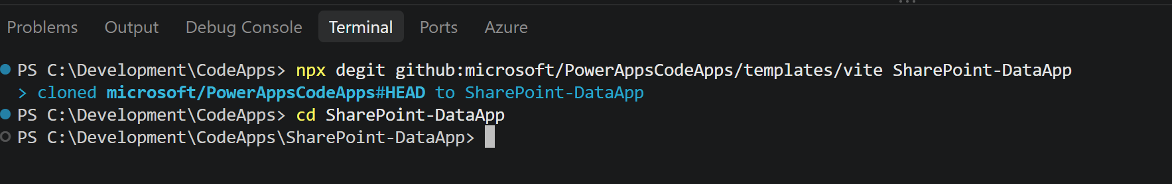
Step 2: Create a SharePoint Site
https://jpower4mvp.sharepoint.com /_layouts/15/sharepoint.aspx/build
- Select Site Select Standard Team Template Give your site a name -> CodeApp
- SharePoint Site Created https://jpower4mvp.sharepoint.com /sites/CodeApp
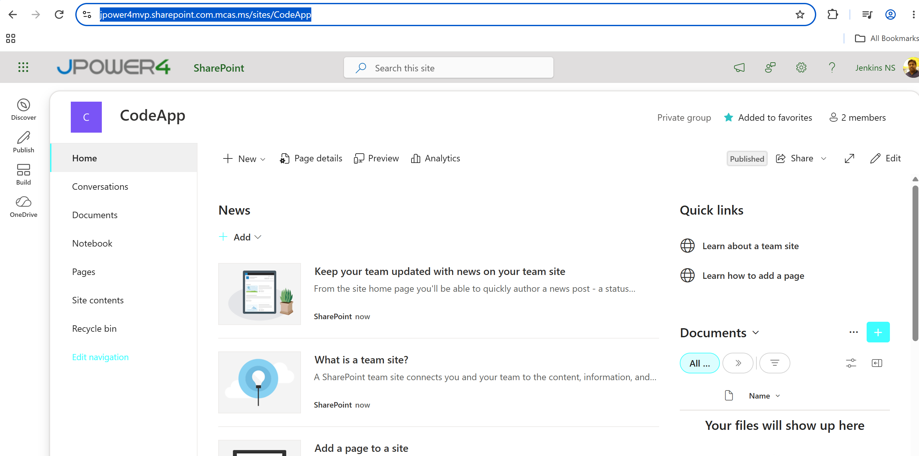

Step 3: Install dependencies and initialize the code app
Install the Power Apps CLI and the project dependencies:
npm install --global @microsoft/power-apps-cli
npm install --global @microsoft/power-apps
npm install
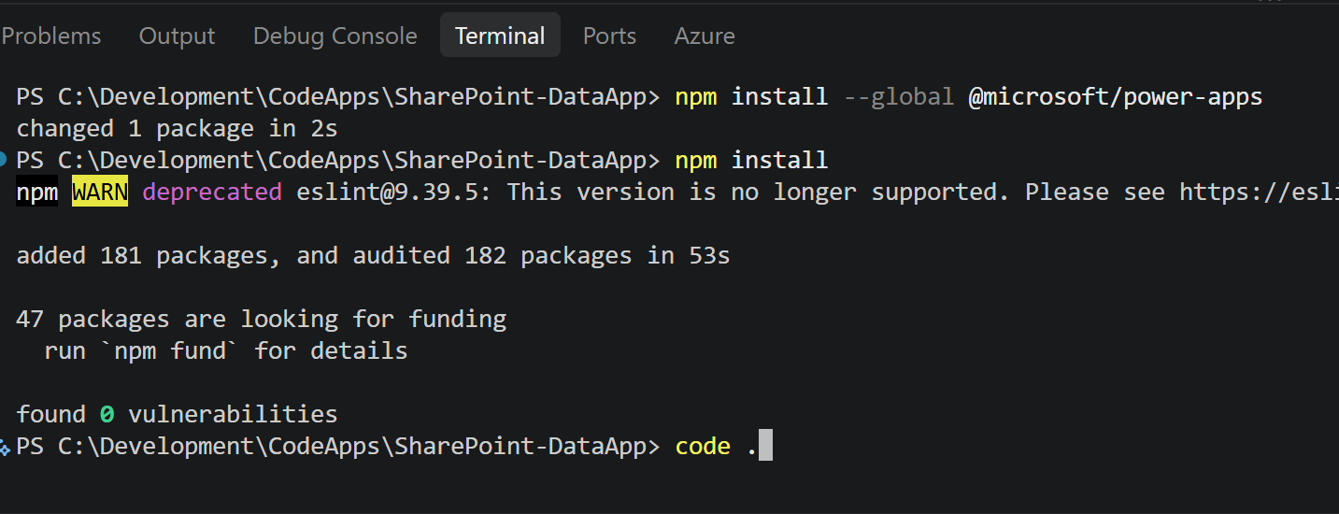
code.
It opens the Project in new window
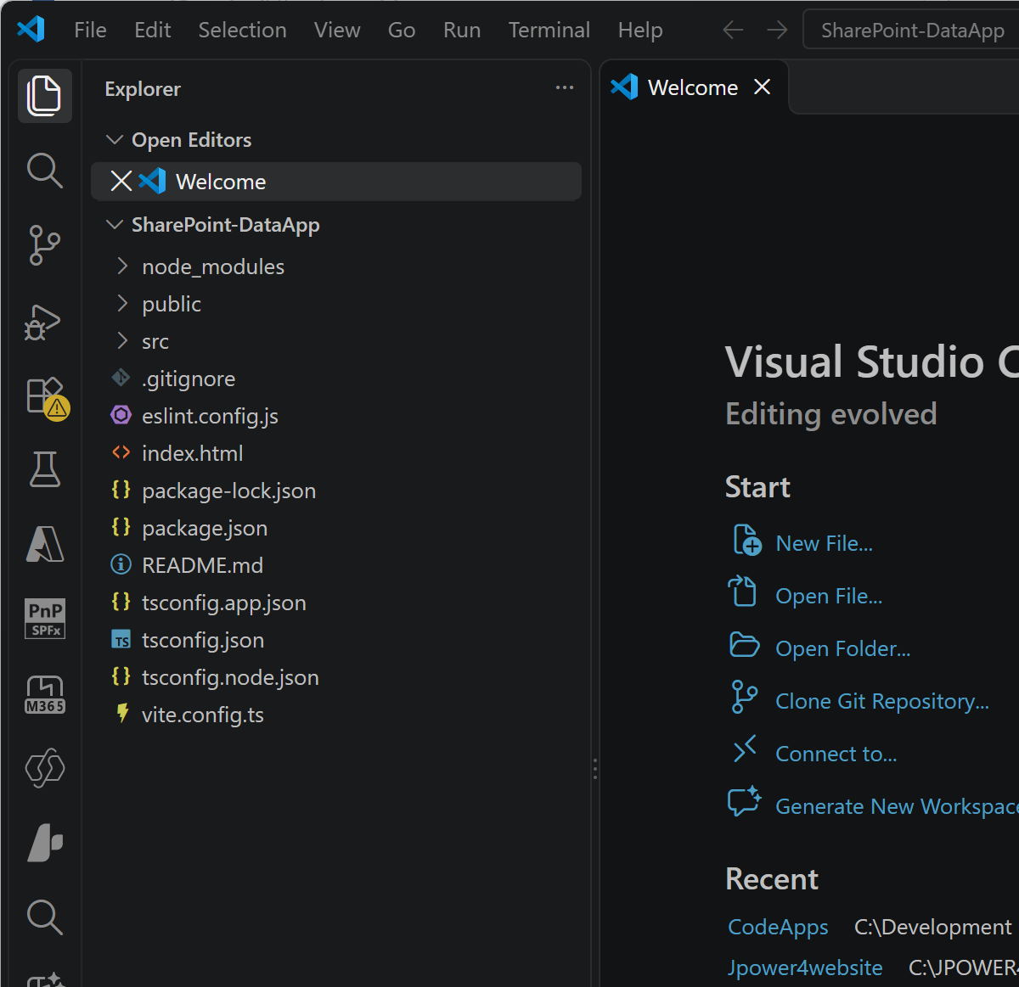

Step 4: Start the app
To to menu Terminal New Terminal
pa app init
Enter Environment ID
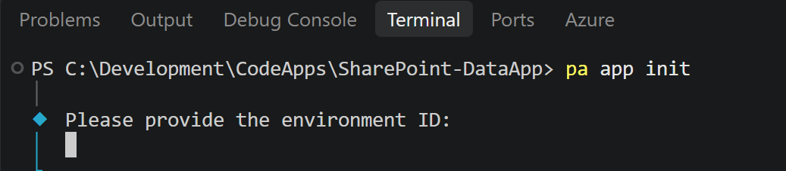
Get the environment ID from your Power Apps your environment
Make.Powerapps.com Settings Session details
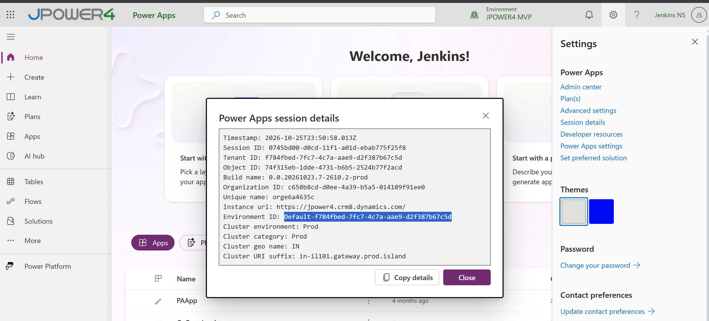
It opens a browser and login
Enter Display Name
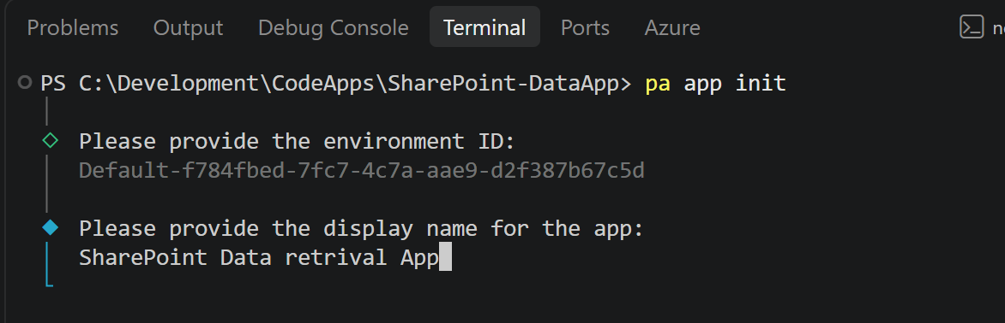
Run the app locally
pa app run
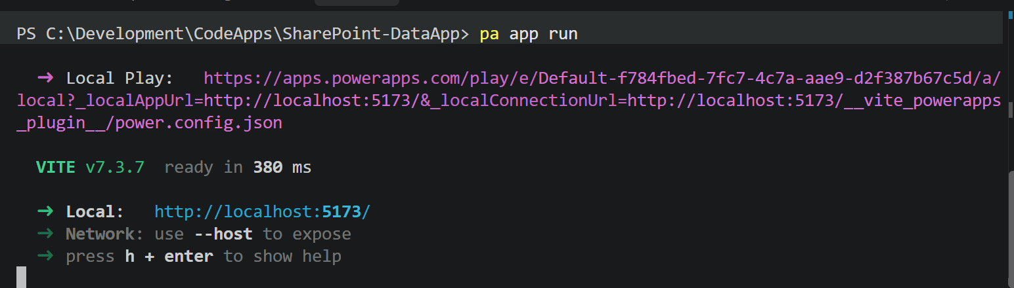
Click the link and open the app locally
Buik
Step 5: Create SharePoint list using Github Copilot
Then Open chat and create the SharePoint list using below prompt
Create a SharePoint list named "Patient Tracker" with the following columns: in site https://jpower4mvp.sharepoint.com.mcas.ms/sites/CodeApp

1. Title (Single Line of Text) - Patient ID (Example: PAT-0001)
2. Patient Name (Single Line of Text)
3. Gender (Choice: Male, Female, Other)
4. Date of Birth (Date Only)
5. Mobile Number (Single Line of Text)
6. Email (Single Line of Text)
7. Address (Multiple Lines of Text)
8. Blood Group (Choice: A+, A-, B+, B-, AB+, AB-, O+, O-)
9. Department (Single Line of Text)
10. Doctor Assigned (Person or Group)
11. Visit Type (Choice: New, Follow-up, Emergency, Consultation)
12. Date (Date Only)
13. Discharge Date (Date Only)
14. Notes (Multiple Lines of Text)
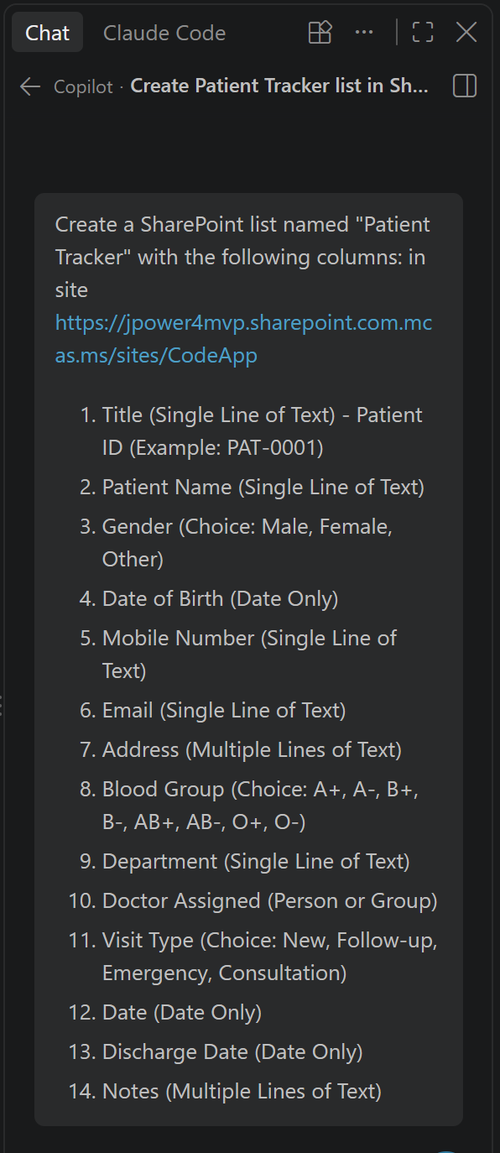
Allow this session and Authenticate
Open it in Browser and Sign in
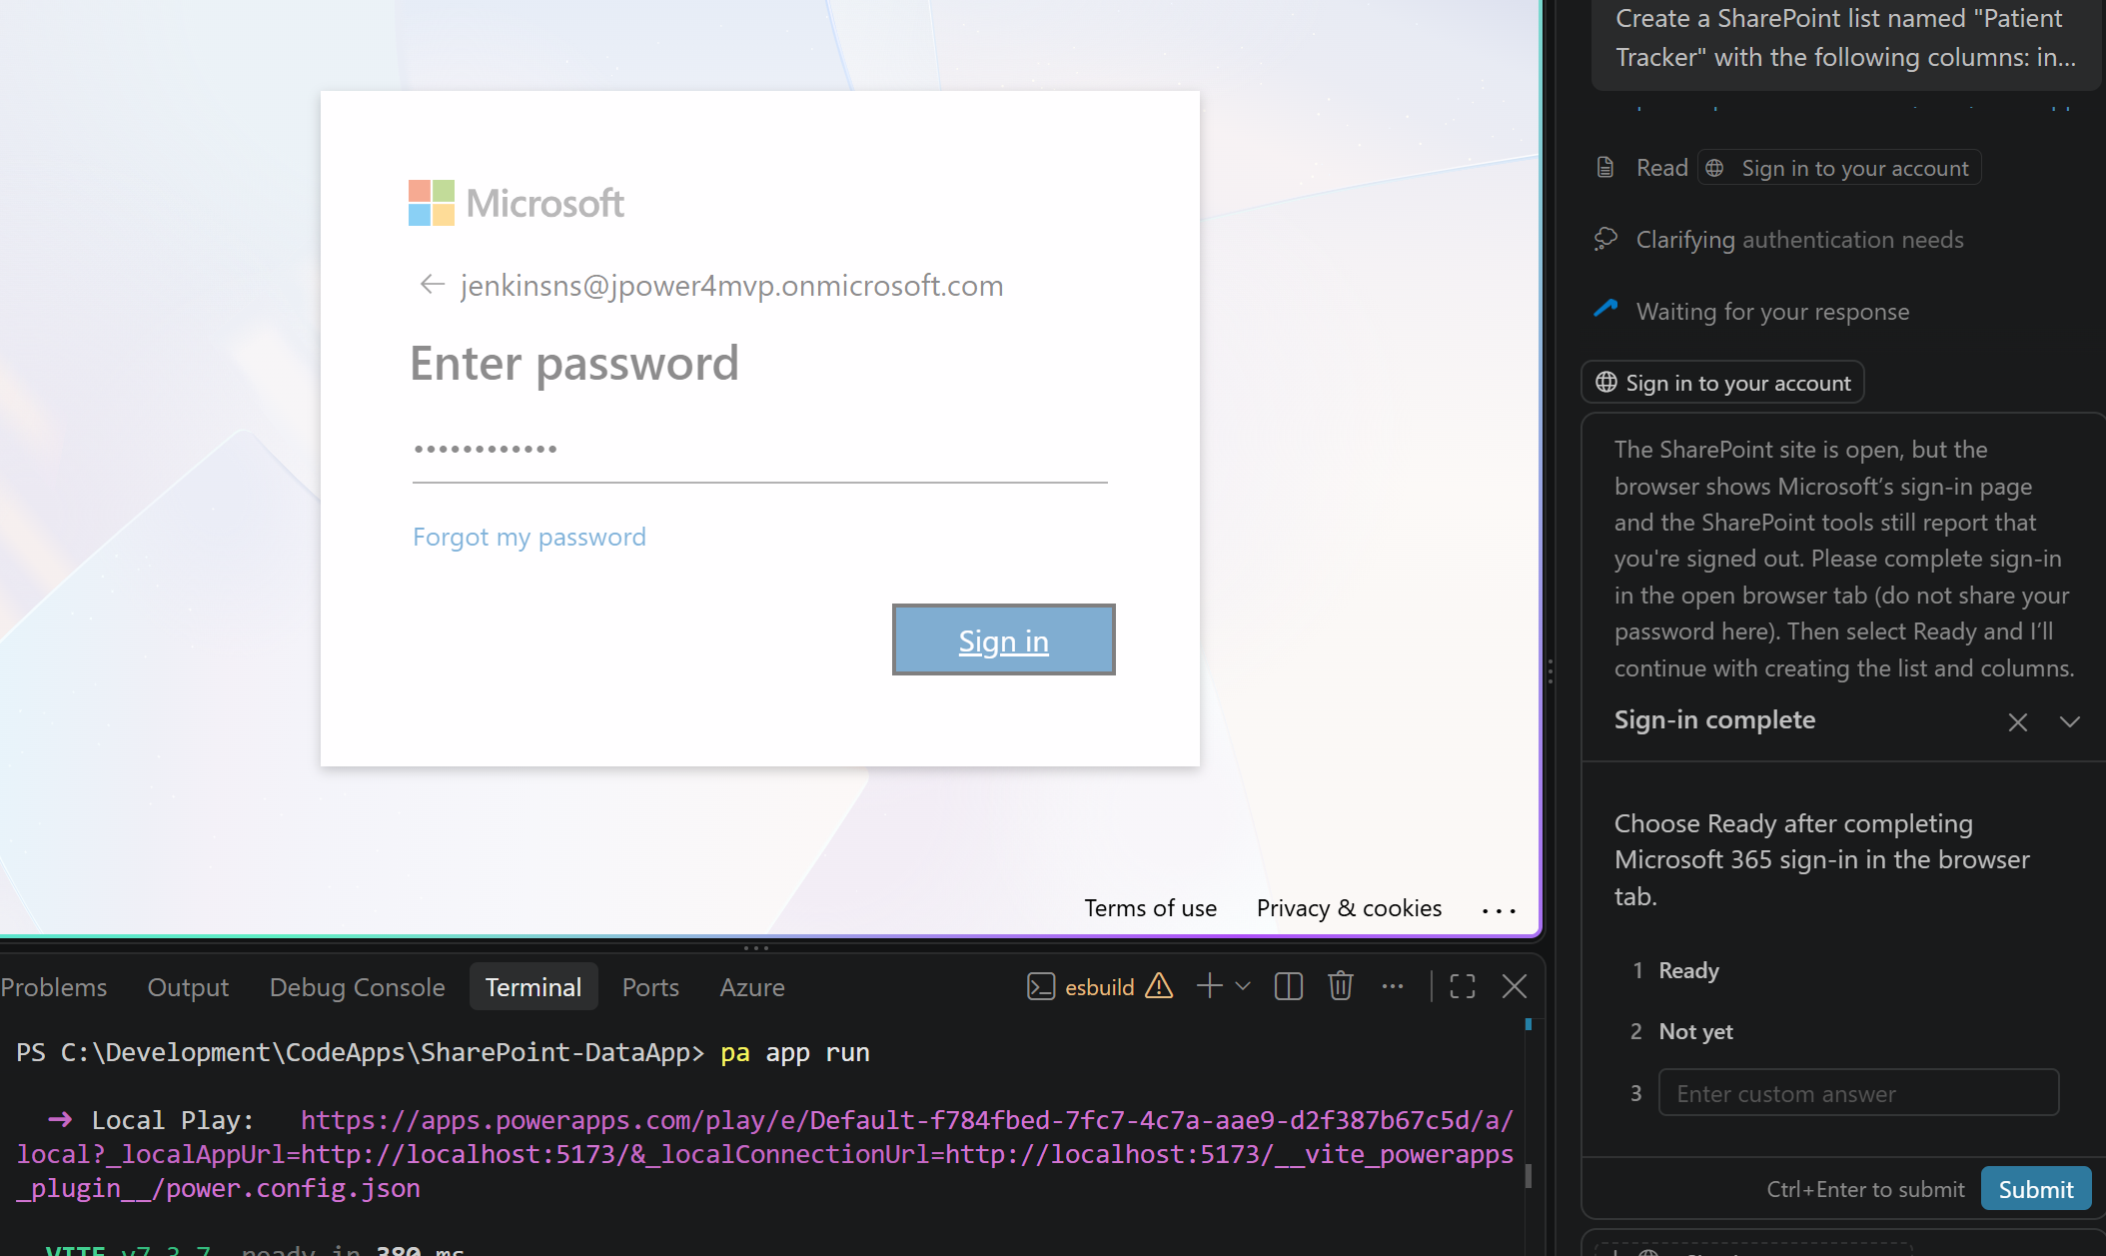
Then Submit in chat window
It will create new SharePoint list Patient Tracker in SharePoint site
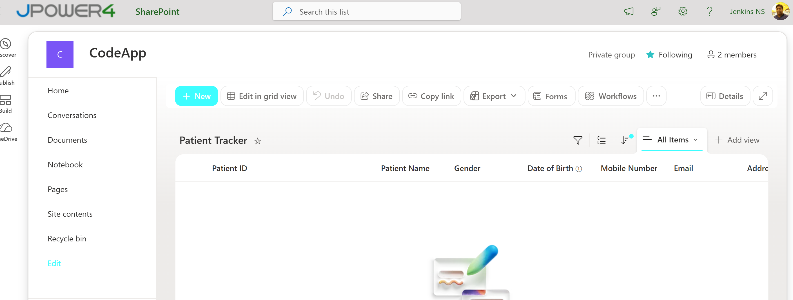
Then add new Prompt -> add 10 sample records
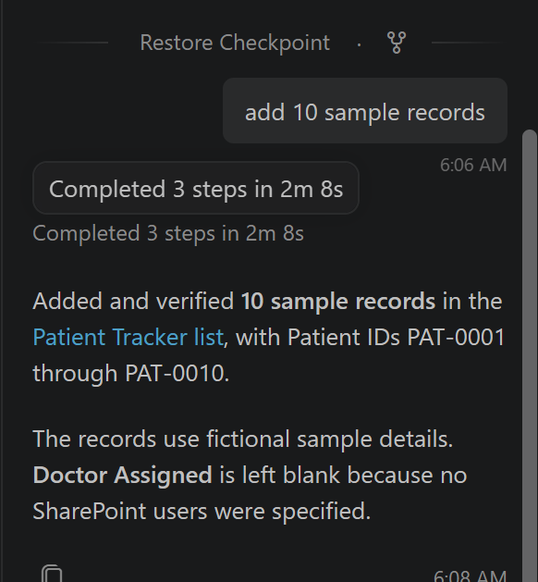
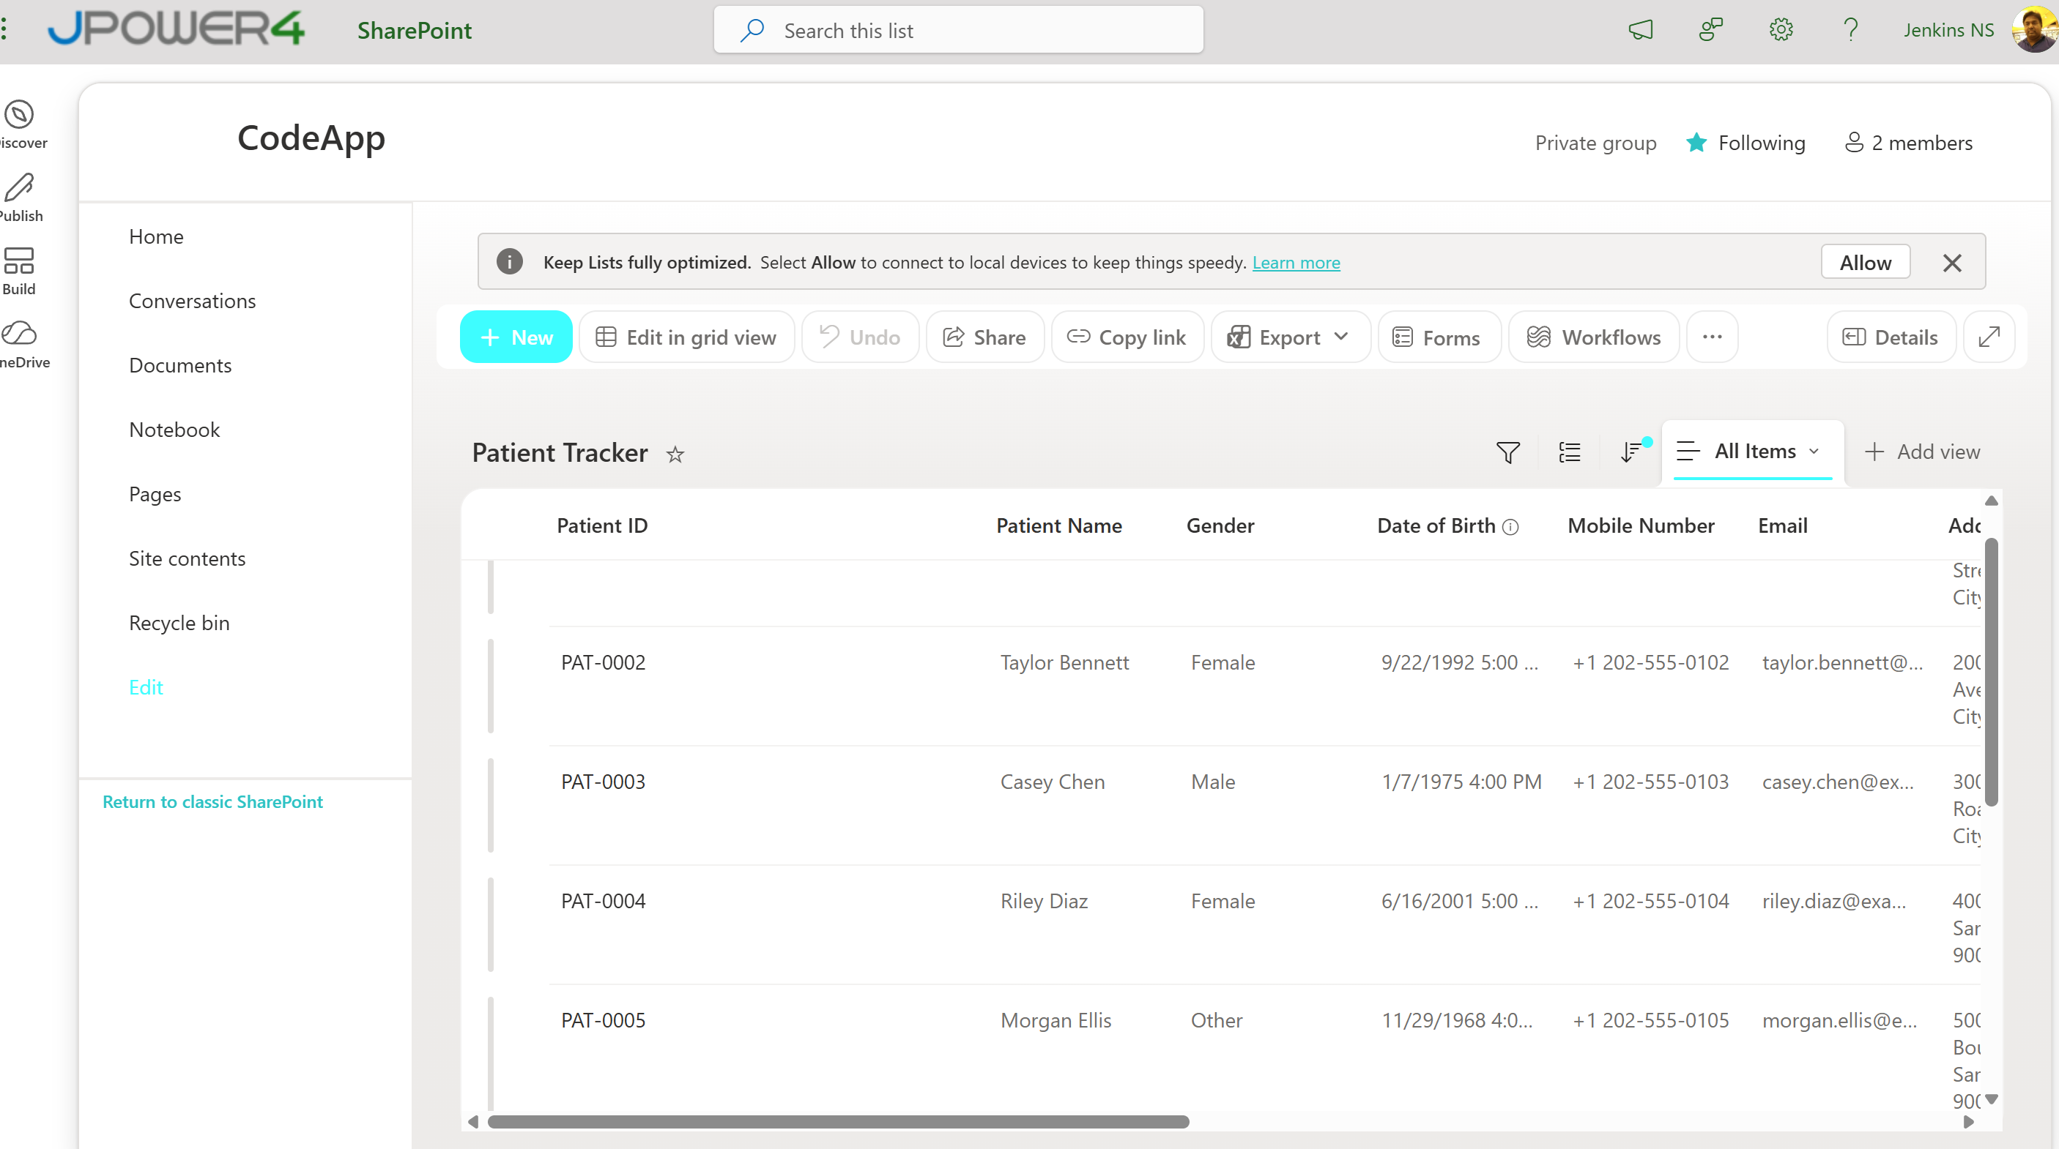
Step 6: Create SharePoint Connection
Go to Make.powerapps.com in the menu select … more Select connections
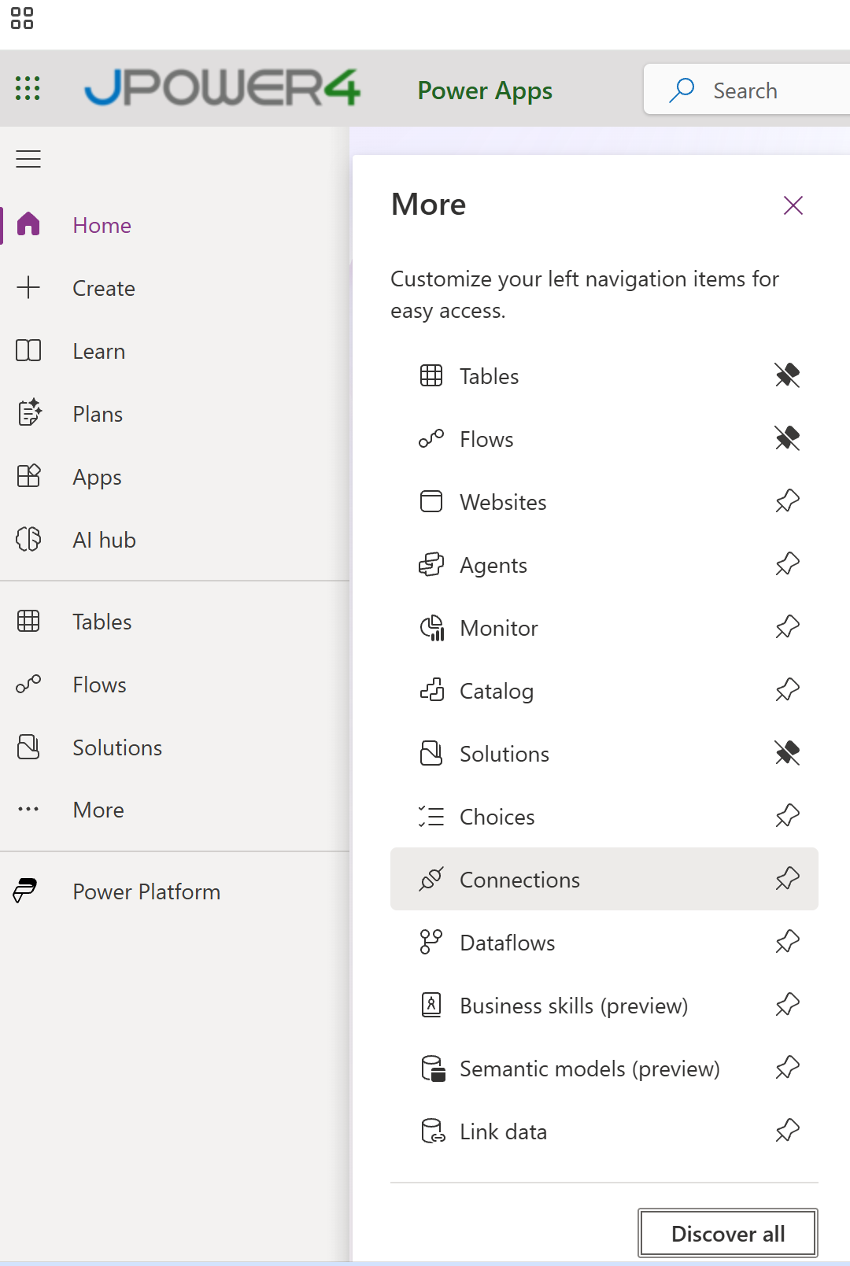
Click New Connection Select SharePoint Select Connect directly (cloud-services) Click Create
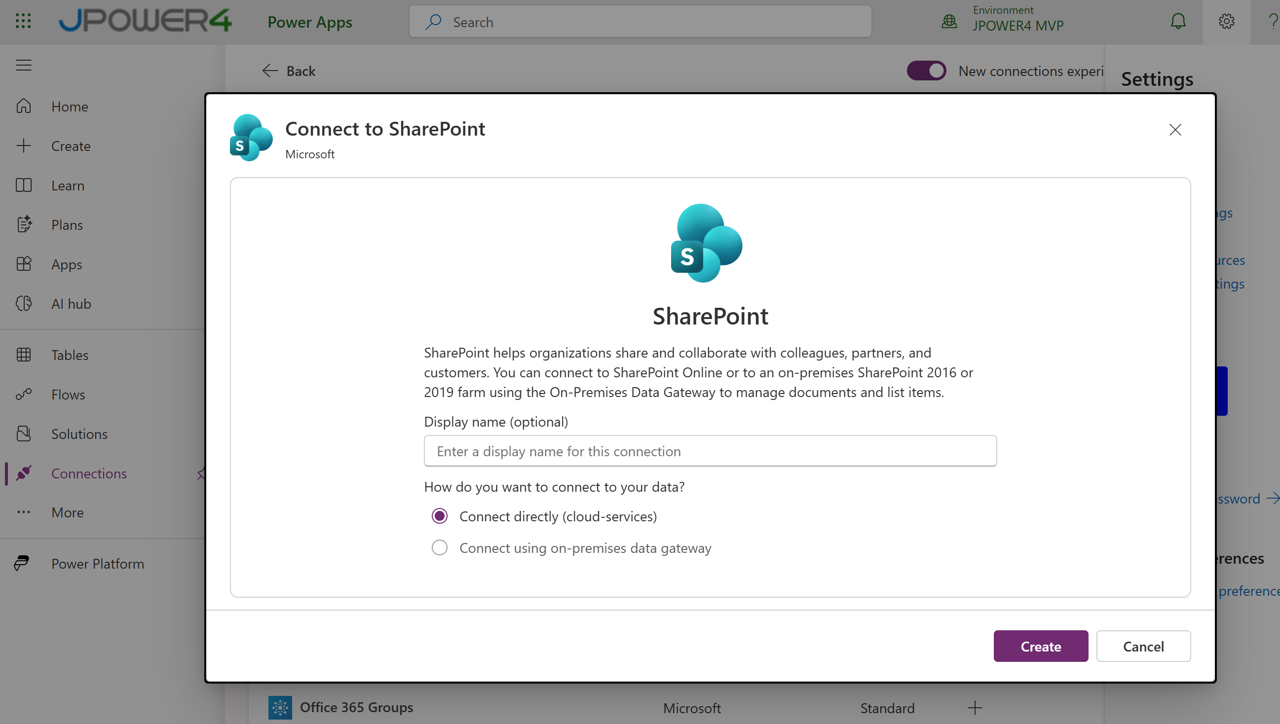
Sign in with your credentials , it create new connection.
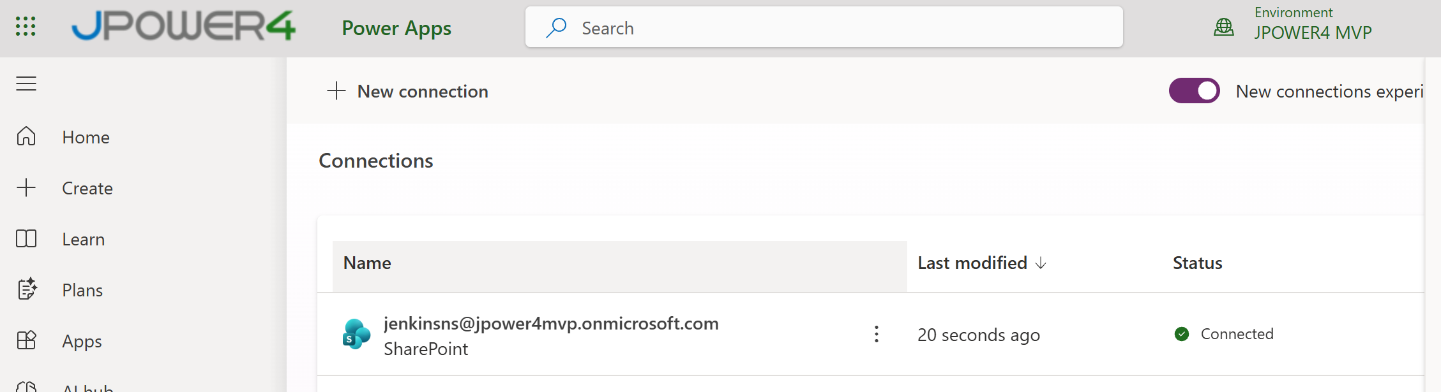
Go to … and rename it “PatientTrackerSPConnector”
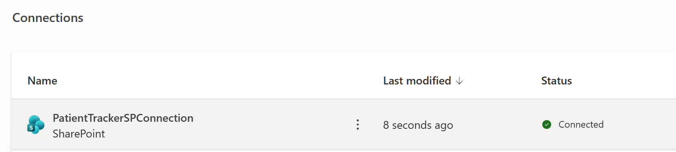
Now our SharePoint connection ready
Enter pa connection list – it displays all connections
pa connection list --search PatientTrackerSPConnector
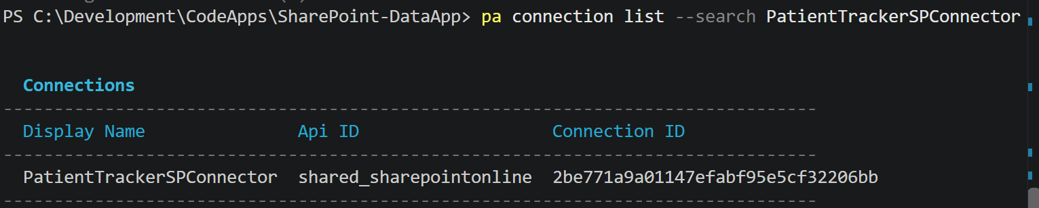
Official Site to Connect the data reference https://learn.microsoft.com/en-us/power-apps/developer/code-apps/how-to/connect-to-data
For SharePoint
pa app add data-source --connector "shared_sharepointonline" --connection-id "2be771a9a01147efabf95e5cf32206bb" --table "Patient%20Tracker" --dataset "https://jpower4mvp.sharepoint.com/sites/CodeApp"
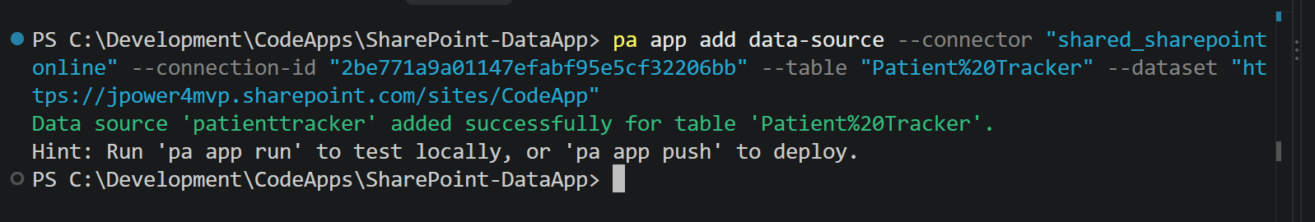
It connected and generated the required code, models and connections
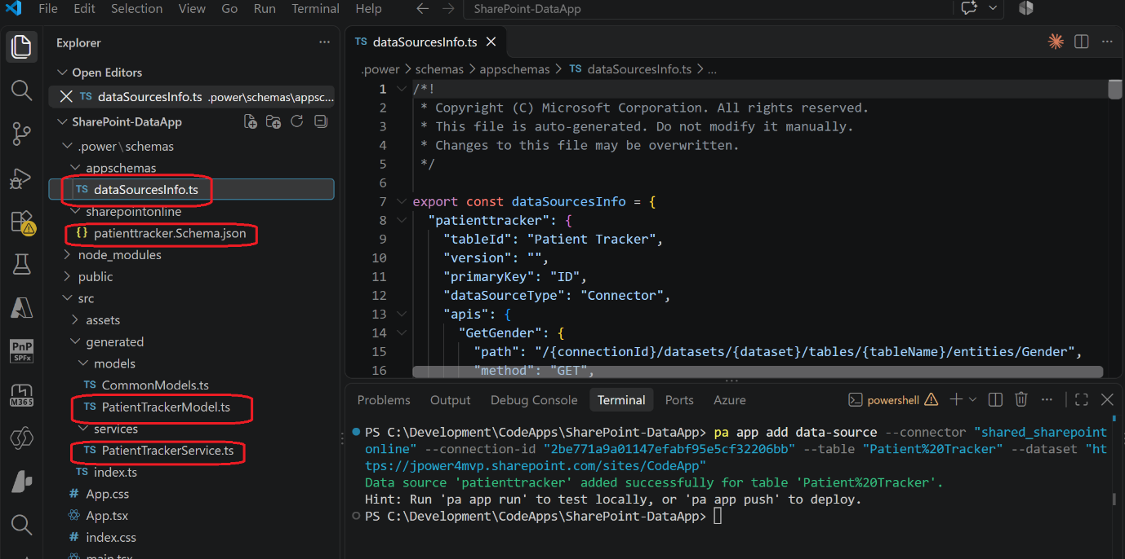
Then open App.css and replace the below styles
* {
box-sizing: border-box;
margin: 0;
padding: 0;
}

body {
font-family: -apple-system, BlinkMacSystemFont, 'Segoe UI', Roboto, sans-serif;
background: #f1f5f9;
color: #1e293b;
}

.app-container {
max-width: 1280px;
margin: 0 auto;
padding: 2rem;
}

.app-header {
margin-bottom: 2rem;
}

.app-title {
font-size: 1.75rem;
font-weight: 700;
color: #0f172a;
}

.app-subtitle {
margin-top: 0.25rem;
font-size: 0.9rem;
color: #64748b;
}

/* Cards grid */
.cards-grid {
display: grid;
grid-template-columns: repeat(auto-fill, minmax(320px, 1fr));
gap: 1.25rem;
}

/* Patient card */
.patient-card {
background: #ffffff;
border-radius: 12px;
box-shadow: 0 1px 3px rgba(0, 0, 0, 0.08), 0 1px 2px rgba(0, 0, 0, 0.04);
overflow: hidden;
transition: box-shadow 0.2s;
}

.patient-card:hover {
box-shadow: 0 4px 12px rgba(0, 0, 0, 0.12);
}

/* Card header */
.card-header {
display: flex;
align-items: center;
gap: 0.75rem;
padding: 1.25rem 1.25rem 1rem;
border-bottom: 1px solid #f1f5f9;
}

.patient-avatar {
width: 42px;
height: 42px;
border-radius: 50%;
background: #3b82f6;
color: #fff;
font-size: 1.1rem;
font-weight: 600;
display: flex;
align-items: center;
justify-content: center;
flex-shrink: 0;
text-transform: uppercase;
}

.card-header-info {
flex: 1;
min-width: 0;
}

.patient-name {
font-size: 1rem;
font-weight: 600;
color: #0f172a;
white-space: nowrap;
overflow: hidden;
text-overflow: ellipsis;
}

.patient-email {
font-size: 0.8rem;
color: #94a3b8;
margin-top: 1px;
white-space: nowrap;
overflow: hidden;
text-overflow: ellipsis;
}

.status-badge {
display: inline-block;
padding: 0.25rem 0.65rem;
border-radius: 9999px;
font-size: 0.7rem;
font-weight: 600;
color: #fff;
white-space: nowrap;
flex-shrink: 0;
text-transform: uppercase;
letter-spacing: 0.03em;
}

/* Card body */
.card-body {
padding: 1rem 1.25rem 1.25rem;
display: flex;
flex-direction: column;
gap: 0.6rem;
}

.info-row {
display: flex;
justify-content: space-between;
align-items: baseline;
gap: 0.5rem;
}

.info-label {
font-size: 0.75rem;
color: #94a3b8;
font-weight: 500;
white-space: nowrap;
flex-shrink: 0;
}

.info-value {
font-size: 0.85rem;
color: #334155;
text-align: right;
overflow: hidden;
text-overflow: ellipsis;
white-space: nowrap;
max-width: 60%;
}

.clinical-notes {
margin-top: 0.5rem;
padding-top: 0.75rem;
border-top: 1px solid #f1f5f9;
display: flex;
flex-direction: column;
gap: 0.3rem;
}

.notes-text {
font-size: 0.8rem;
color: #64748b;
line-height: 1.5;
display: -webkit-box;
-webkit-line-clamp: 3;
-webkit-box-orient: vertical;
overflow: hidden;
}

/* Loading / error / empty states */
.state-message {
display: flex;
flex-direction: column;
align-items: center;
justify-content: center;
padding: 4rem 2rem;
gap: 1rem;
color: #64748b;
font-size: 0.95rem;
}

.state-message.error {
color: #dc2626;
}

.spinner {
width: 36px;
height: 36px;
border: 3px solid #e2e8f0;
border-top-color: #3b82f6;
border-radius: 50%;
animation: spin 0.8s linear infinite;
}

@keyframes spin {
to { transform: rotate(360deg); }
}
Then open App.tsx
Replace below code
import { useState, useEffect } from 'react'
import { PatientTrackerService } from './generated/services/PatientTrackerService'
import type { PatientTrackerRead } from './generated/models/PatientTrackerModel'
import './App.css'

function statusColor(status?: string): string {
switch (status?.toLowerCase()) {
case 'admitted': return '#2563eb'
case 'discharged': return '#16a34a'
case 'critical': return '#dc2626'
case 'observation': return '#d97706'
default: return '#6b7280'
}
}

function formatDate(dateStr?: string): string {
if (!dateStr) return '—'
return new Date(dateStr).toLocaleDateString('en-US', { year: 'numeric', month: 'short', day: 'numeric' })
}

function PatientCard({ patient }: { patient: PatientTrackerRead }) {
const status = patient.Visit_x0020_Type?.Value
const doctor = patient.Doctor_x0020_Assigned?.DisplayName

return (
<div className="patient-card">
<div className="card-header">
<div className="patient-avatar">{patient.Title?.charAt(0) ?? '?'}</div>
<div className="card-header-info">
<h3 className="patient-name">{patient.Title ?? 'Unknown Patient'}</h3>
<p className="patient-email">{patient.Email ?? '—'}</p>
</div>
{status && (
<span className="status-badge" style={{ backgroundColor: statusColor(status) }}>
{status}
</span>
)}
</div>

<div className="card-body">
<div className="info-row">
<span className="info-label">Date of Birth</span>
<span className="info-value">{formatDate(patient.Date_x0020_of_x0020_Birth)}</span>
</div>
<div className="info-row">
<span className="info-label">Gender</span>
<span className="info-value">{patient.Gender?.Value ?? '—'}</span>
</div>
<div className="info-row">
<span className="info-label">Assigned Doctor</span>
<span className="info-value">{doctor ?? '—'}</span>
</div>
<div className="info-row">
<span className="info-label">Primary Diagnosis</span>
<span className="info-value">{patient.Notes ?? '—'}</span>
</div>
<div className="info-row">
<span className="info-label">Admission Date</span>
<span className="info-value">{formatDate(patient.Date)}</span>
</div>
<div className="info-row">
<span className="info-label">Discharge Date</span>
<span className="info-value">{formatDate(patient.Discharge_x0020_Date)}</span>
</div>
{patient.Notes && (
<div className="clinical-notes">
<span className="info-label">Clinical Notes</span>
<p className="notes-text">{patient.Notes}</p>
</div>
)}
</div>
</div>
)
}

function App() {
const [patients, setPatients] = useState<PatientTrackerRead[]>([])
const [loading, setLoading] = useState(true)
const [error, setError] = useState<string | null>(null)

useEffect(() => {
PatientTrackerService.getAll()
.then((result) => {
setPatients(result.data ?? [])
})
.catch((err) => {
setError(err?.message ?? 'Failed to load patient data.')
})
.finally(() => {
setLoading(false)
})
}, [])

return (
<div className="app-container">
<header className="app-header">
<h1 className="app-title">Patient Tracker</h1>
<p className="app-subtitle">{!loading && !error ? `${patients.length} patient${patients.length !== 1 ? 's' : ''}` : ''}</p>
</header>

{loading && (
<div className="state-message">
<div className="spinner" />
<p>Loading patients...</p>
</div>
)}

{error && (
<div className="state-message error">
<p>{error}</p>
</div>
)}

{!loading && !error && patients.length === 0 && (
<div className="state-message">
<p>No patients found.</p>
</div>
)}

{!loading && !error && patients.length > 0 && (
<div className="cards-grid">
{patients.map((patient) => (
<PatientCard key={patient.ID ?? patient['{Identifier}']} patient={patient} />
))}
</div>
)}
</div>
)
}

export default App

update the names if any property shows error
Save it
Run the app pa app run
It opens in new browser and list all patient information.
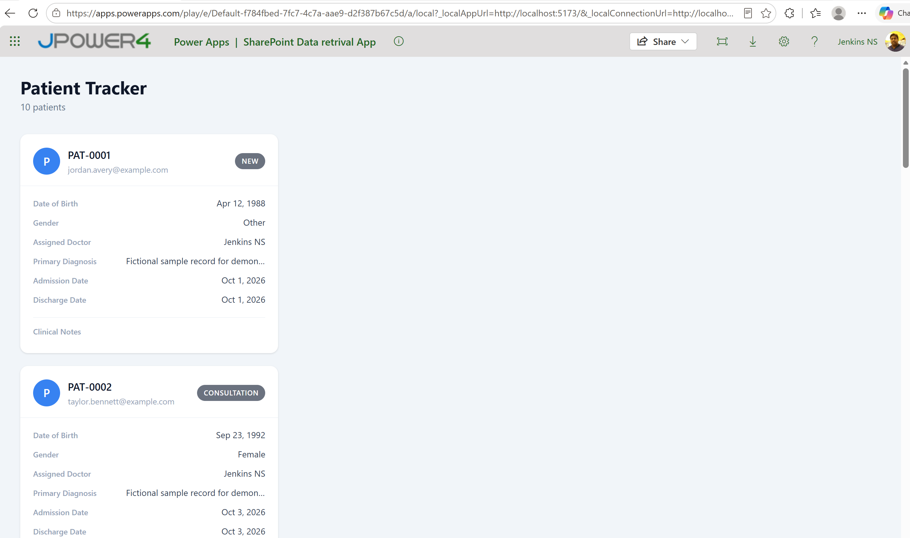
Add new record in SharePoint and refresh and see the result

